**UNEARTHING THE ENVIRONMENTAL IMPACT OF HUMAN ACTIVITY A GLOBAL CO2 EMISSION ANALYSIS**

**INTRODUCTION**

**1.1 Overview:**

Global warming is one of the biggest challenges currently being faced by the human race, although correlation is not causation, a likely cause of global warming is due to increased atmospheric carbon dioxide from human activities. CO2 Emission refers to the Carbon Dioxide emitted throughout the world. For this analysis we will be focusing on CO2 Emissions and its effect on the world we live in as well as some key factors and stats that may play a role in the emission of CO2 globally. Fossil fuel use is the primary source of CO2. The data throws light onto how much fossil fuels are burnt, per year per nation, which amounts to an increase in CO2 every year. This will help researchers and environment experts to predict global warming. So countries should set a goal to decrease this amount yearly. Analysing Global Co2 Emission across countries from 1975 to 2020. This dataset contains a record of Co2 Emission by each Country and Region of Earth, here we are going to analyse and visualise Country wise, Region wise and Overall Co2 Emission on Earth.

* 1. **Purpose:**
* The purpose of unearthing the environmental impact of human activity and conducting a global CO2 emission analysis is to understand the extent to which human activities are affecting the natural environment, particularly in terms of climate change.
* The burning of fossil fuels for energy production, transportation, and industrial processes has led to the release of large amounts of carbon dioxide (CO2) into the atmosphere, contributing to the greenhouse effect and global warming.
* By analyzing global CO2 emissions and other environmental data, scientists and policymakers can better understand the scale and impact of human activities on the environment, and develop strategies to mitigate and adapt to the effects of climate change.
* Understanding the environmental impact of human activity and reducing greenhouse gas emissions is critical to ensuring a sustainable future for the planet and all

**PROBLEM DEFINITION AND DESIGN THINKING**

**2.1 Empathy Map:**

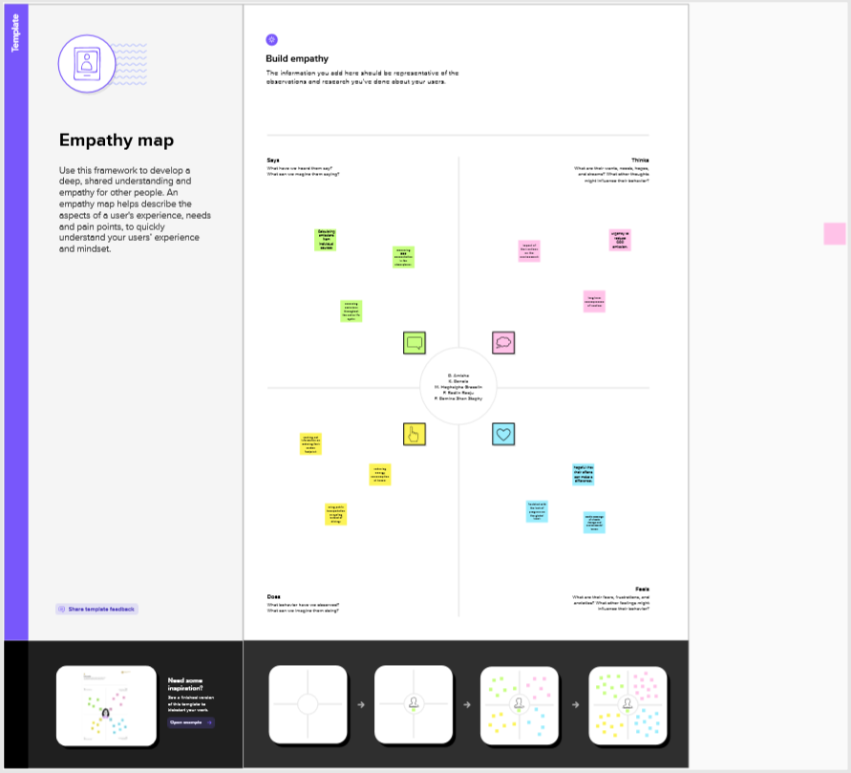

**2.2 Ideation and Brainstorming Map:**

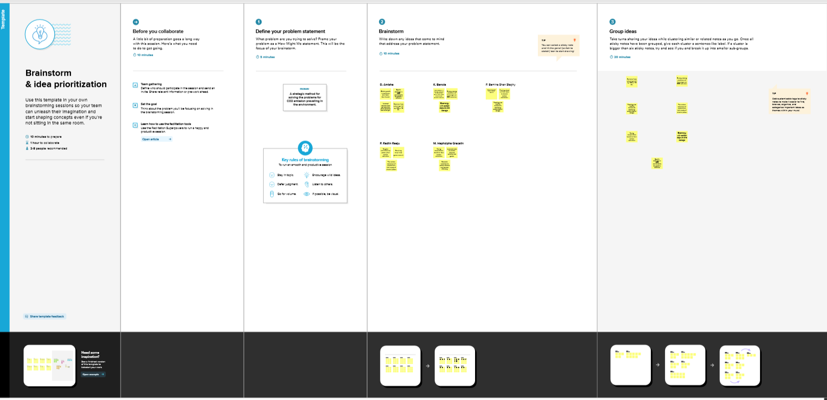

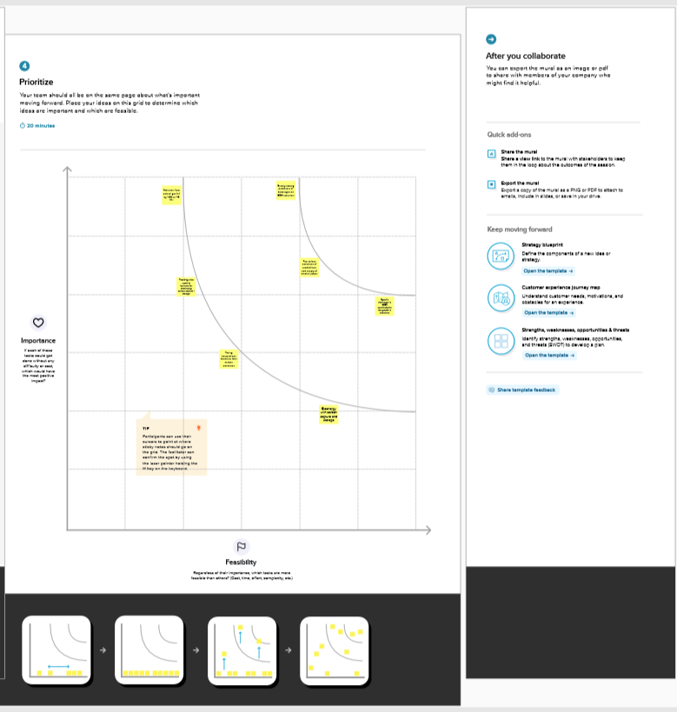

**RESULT**

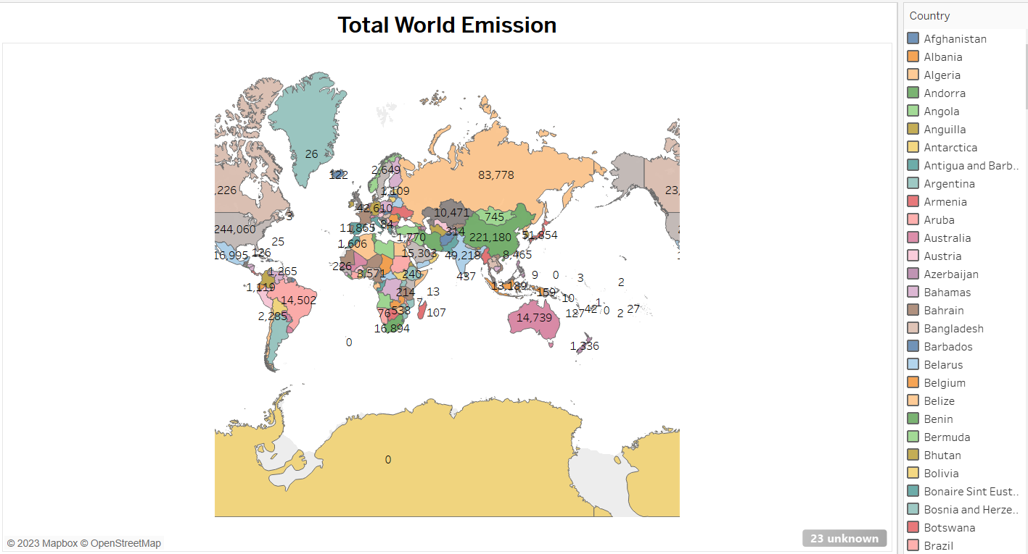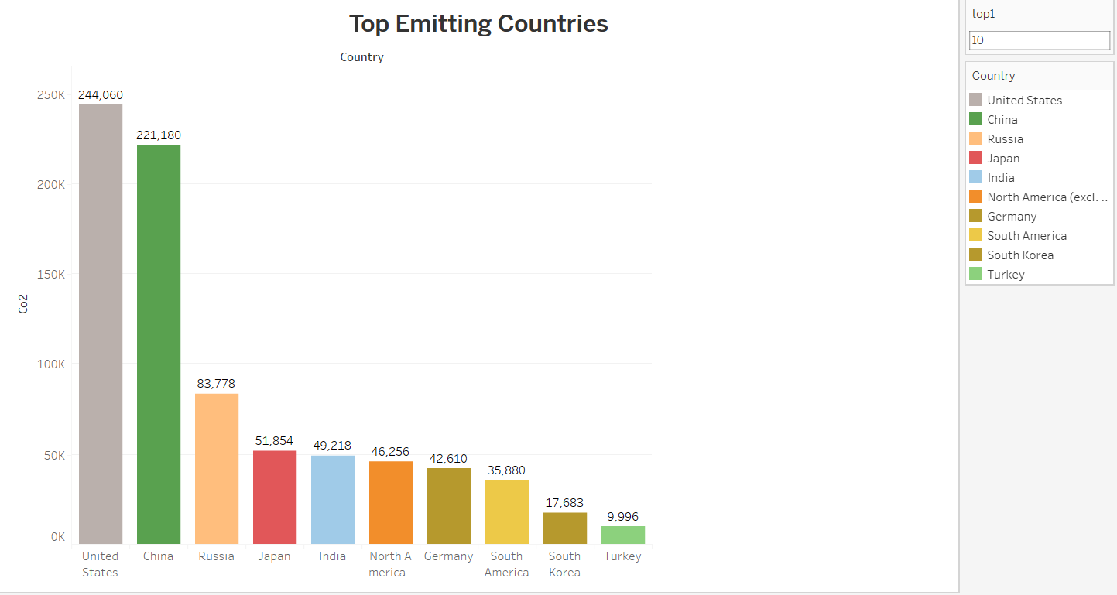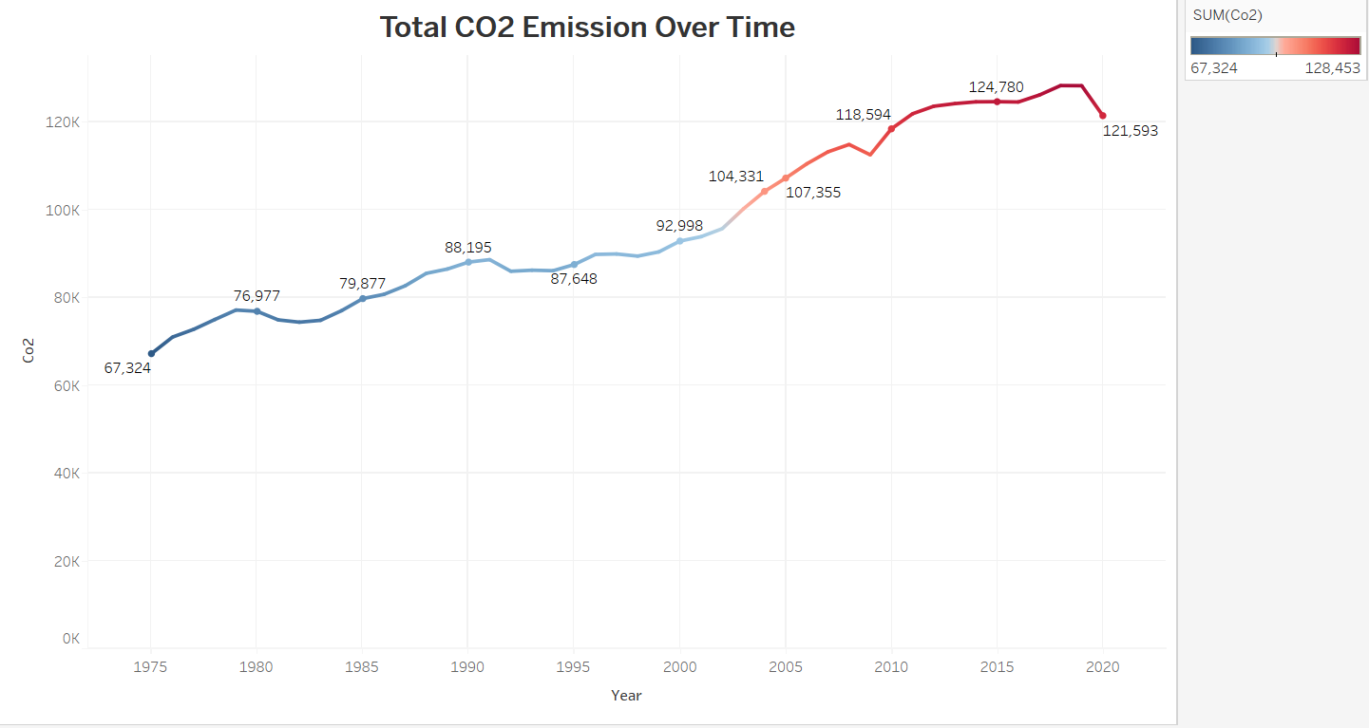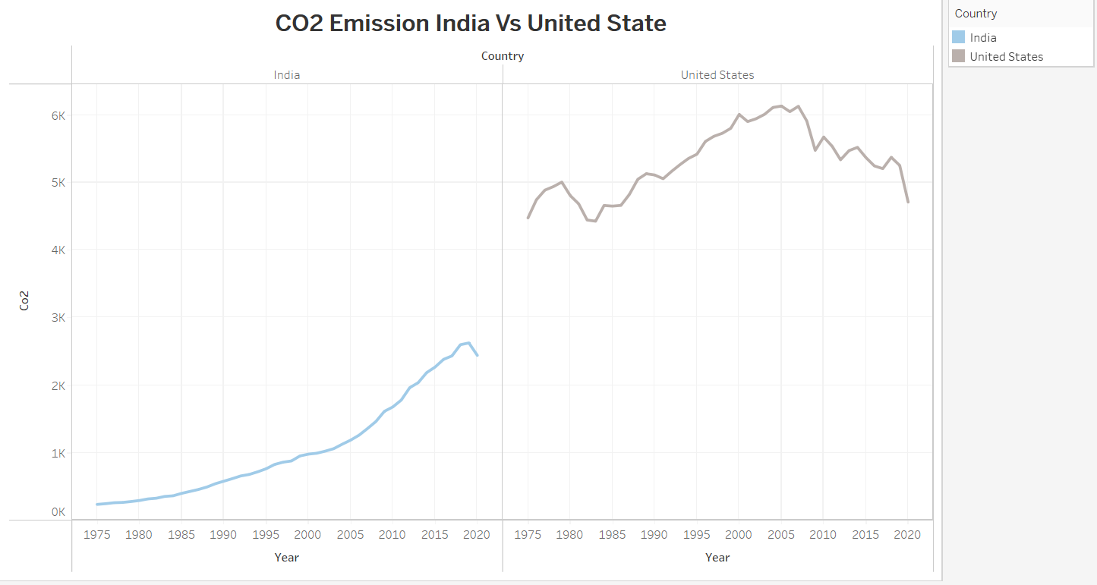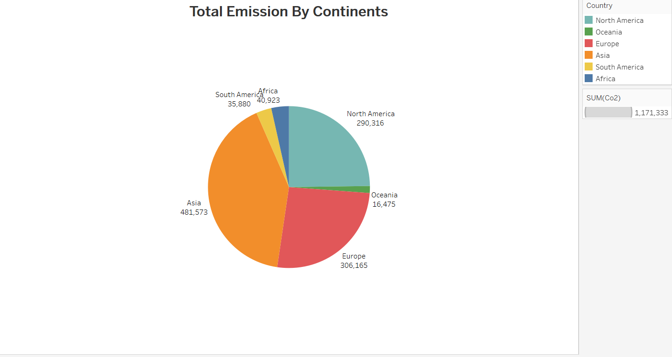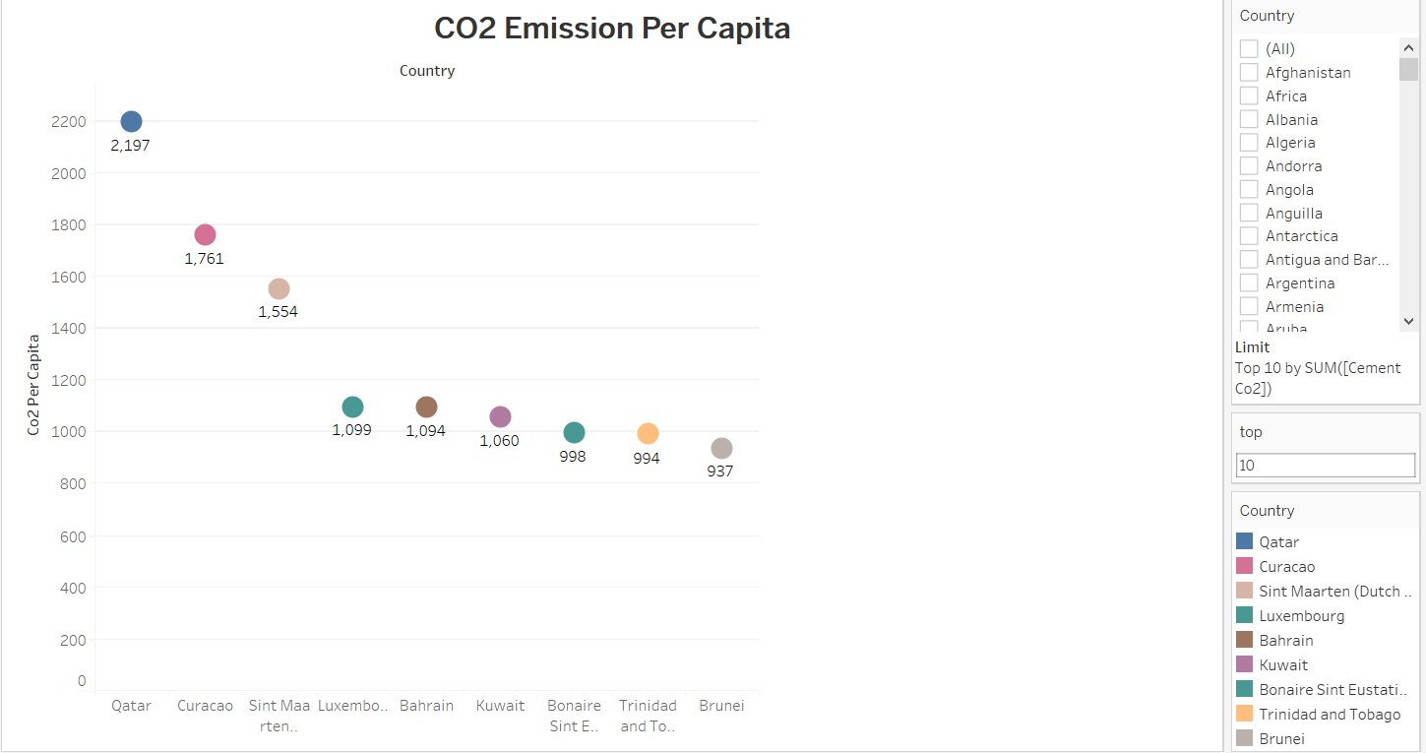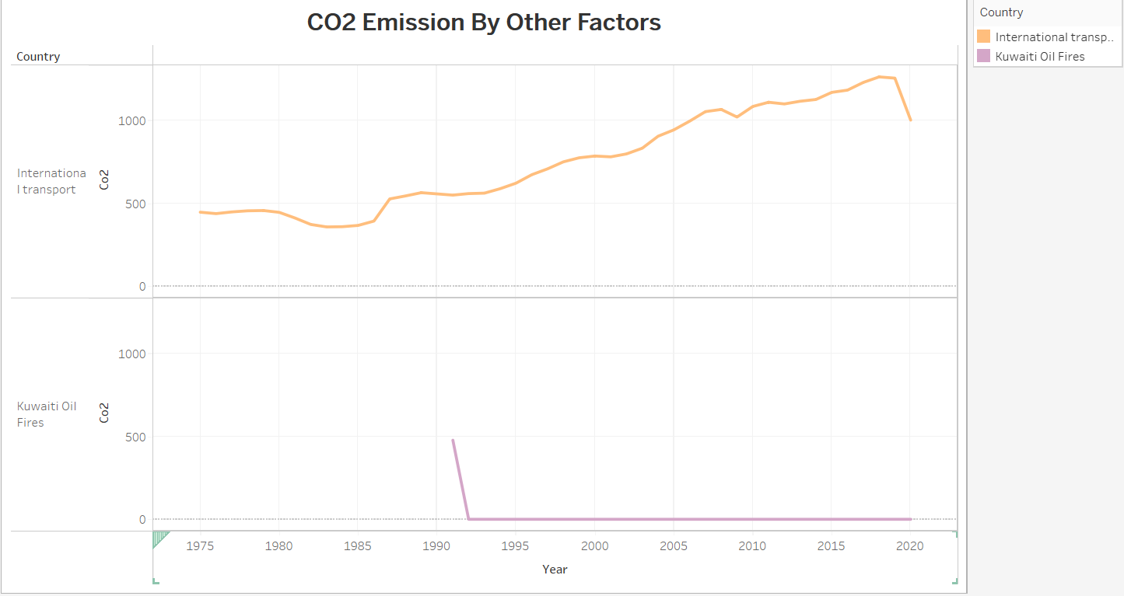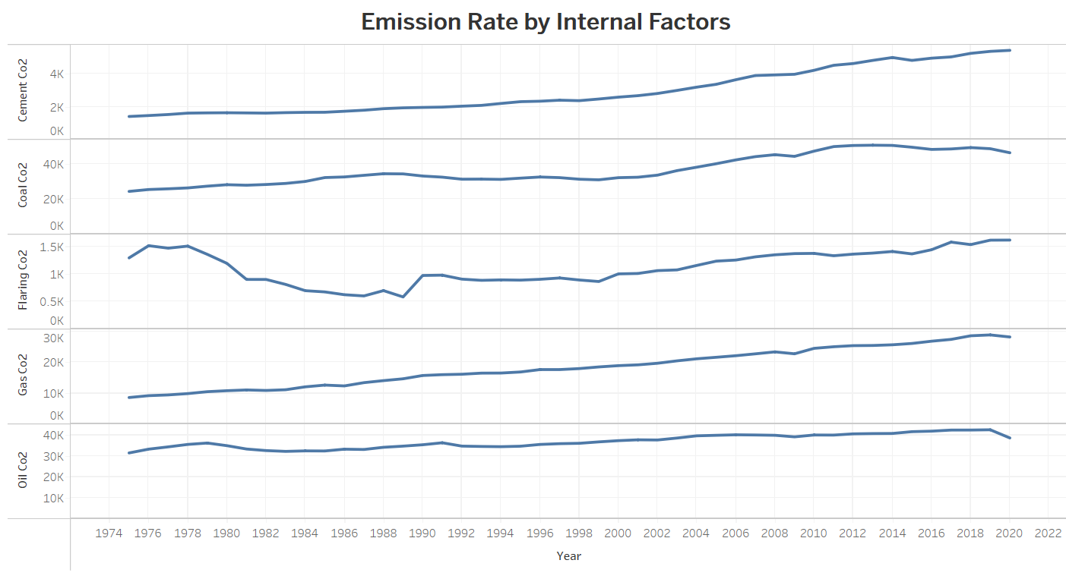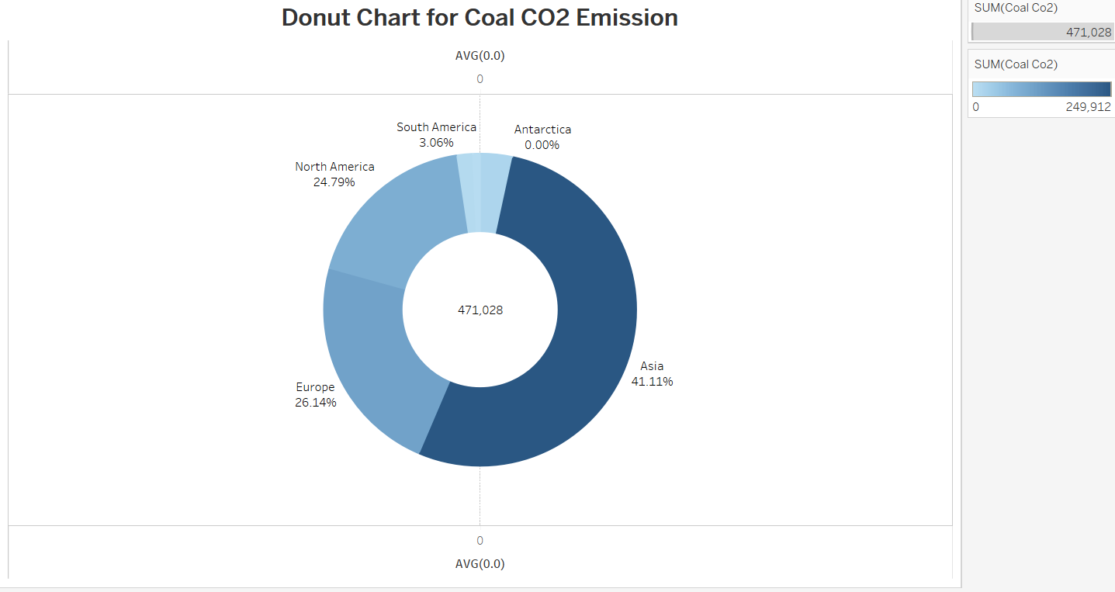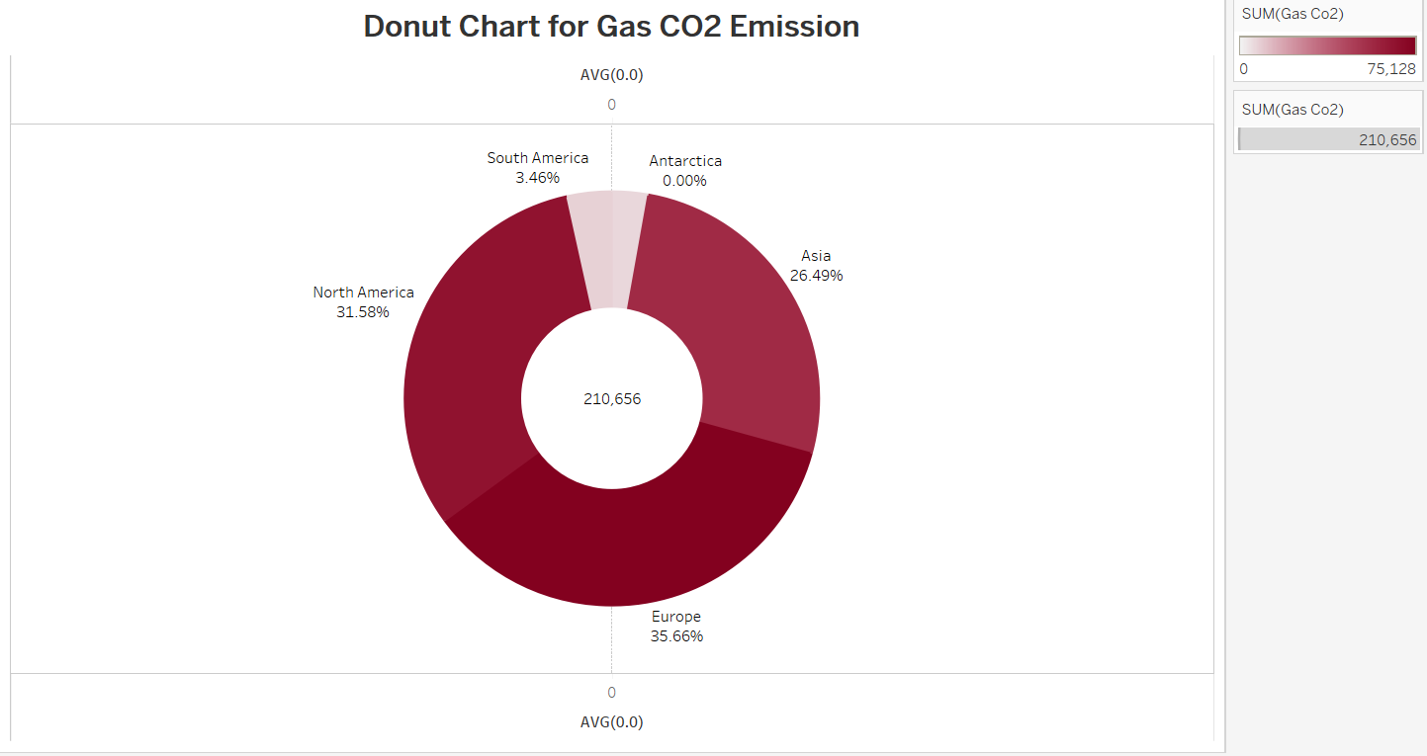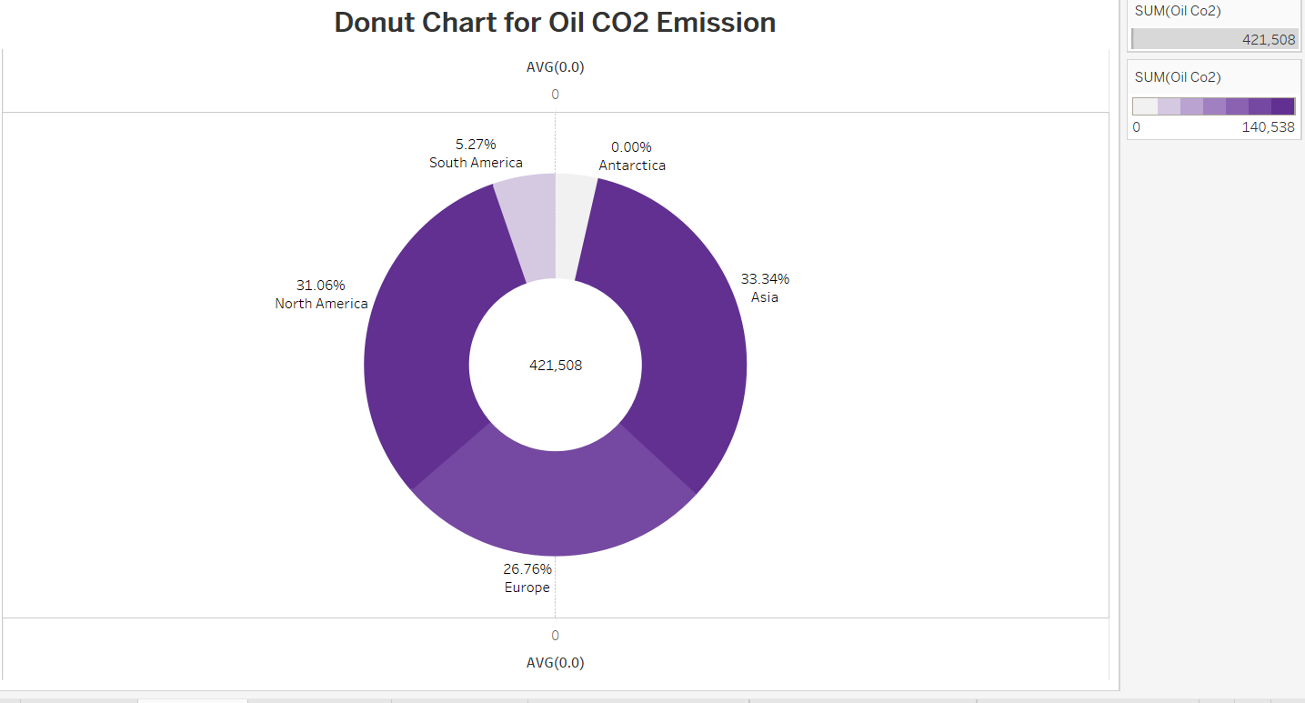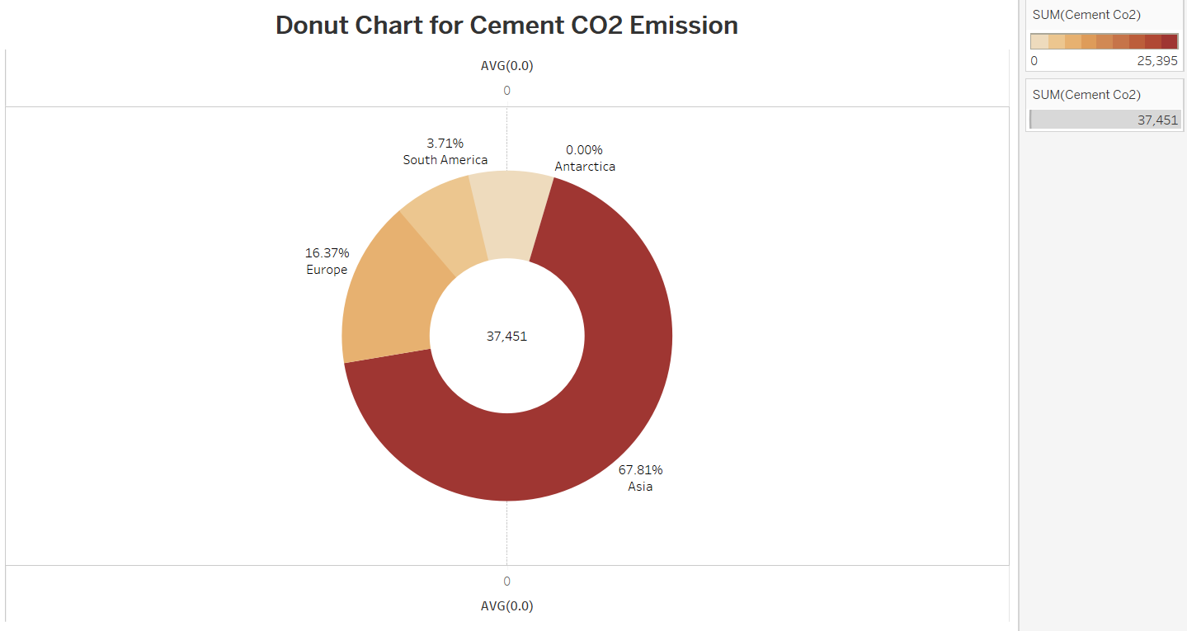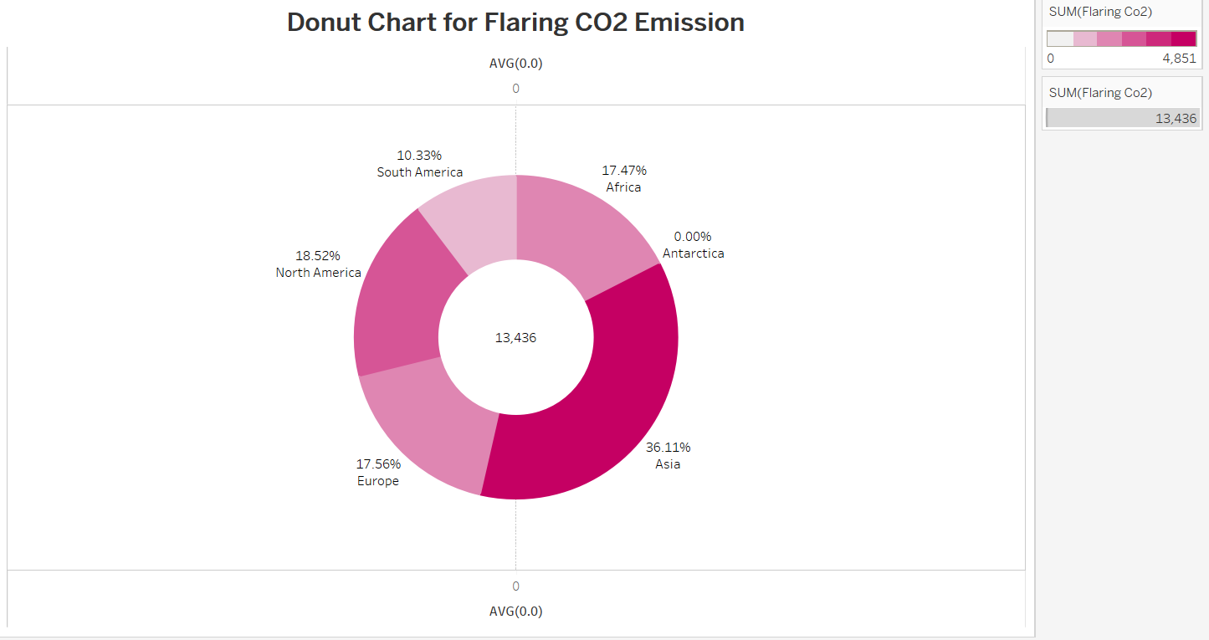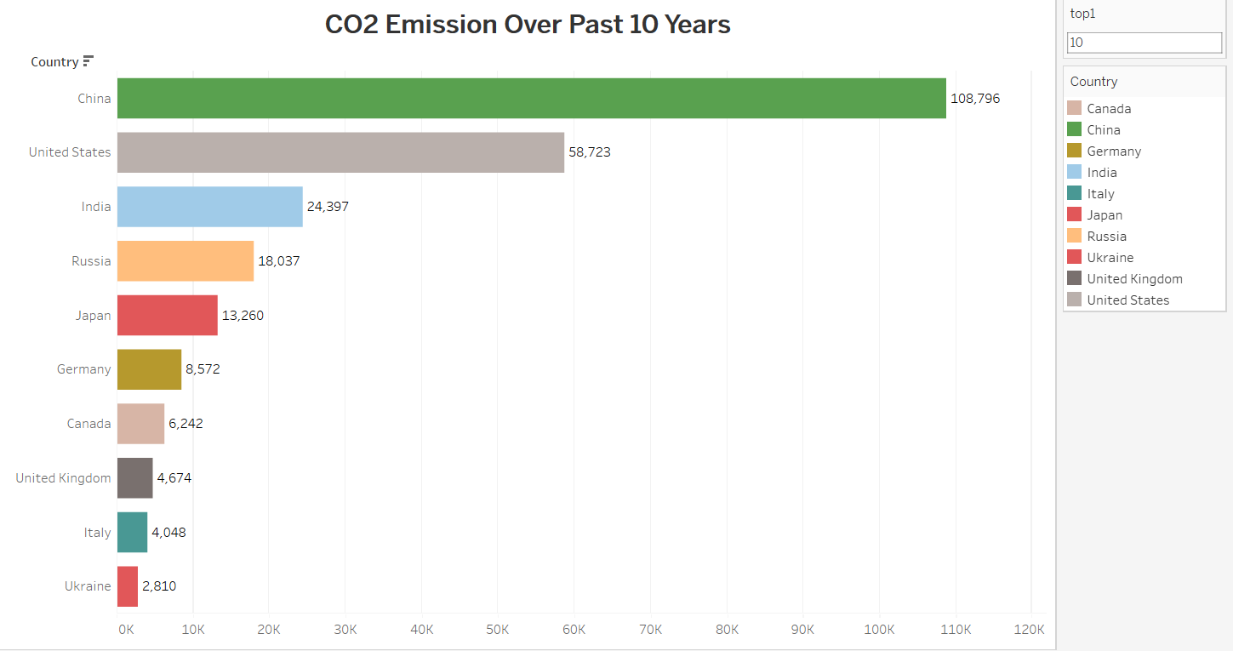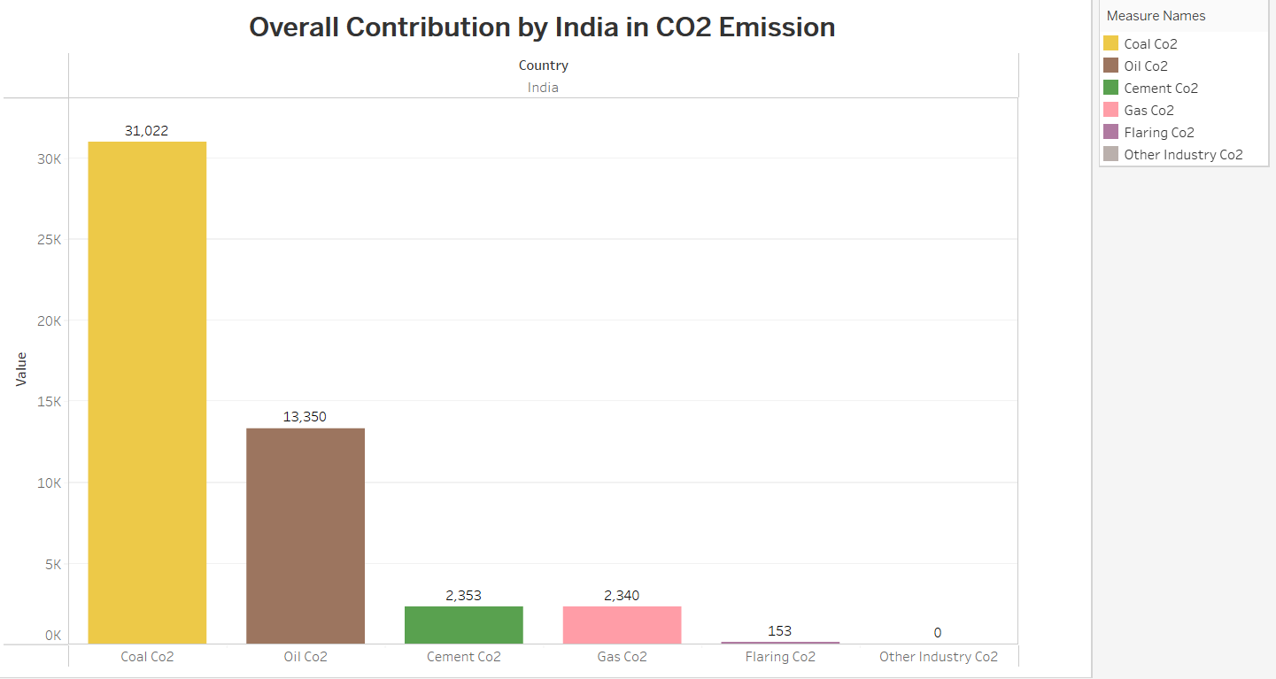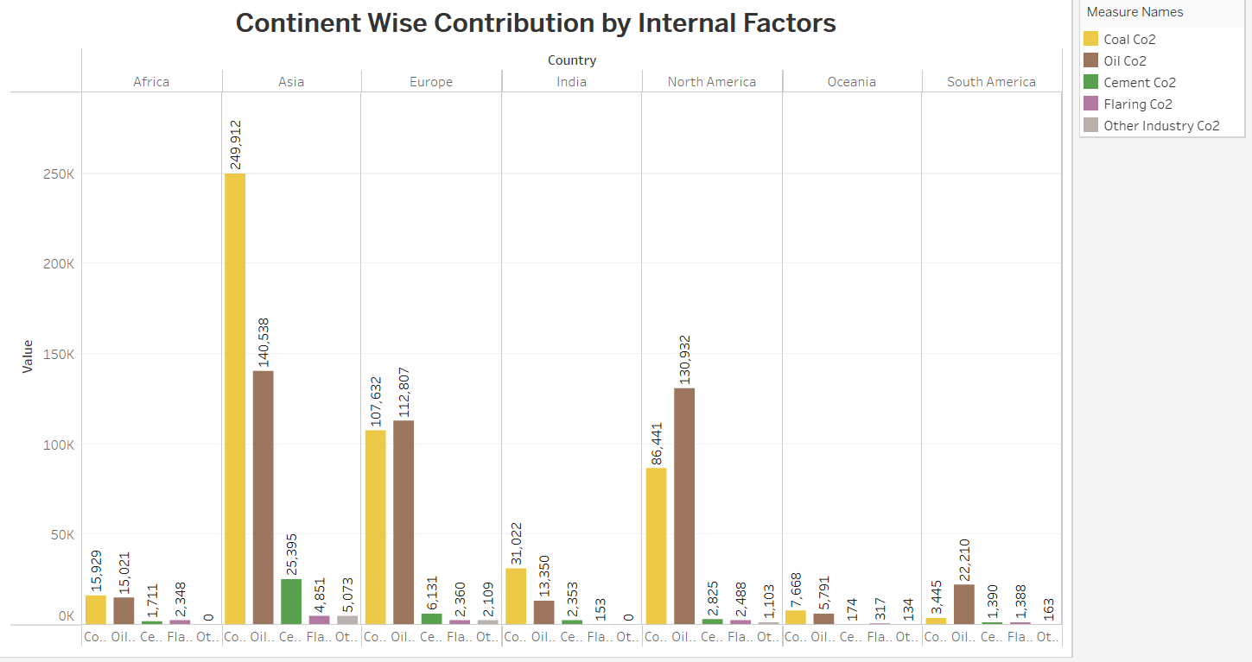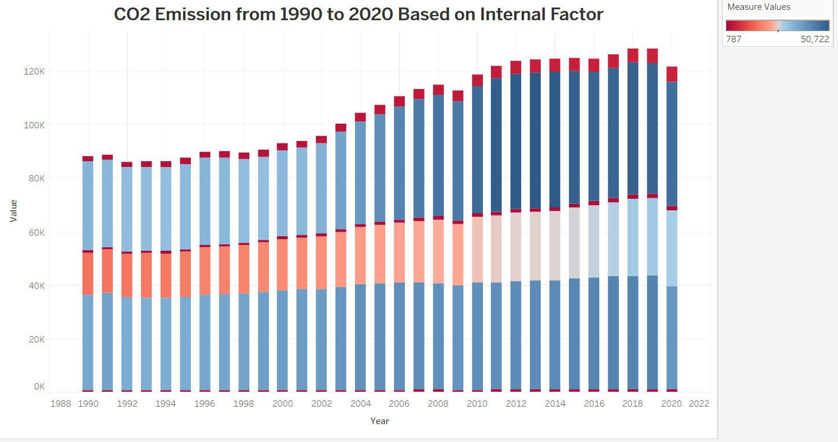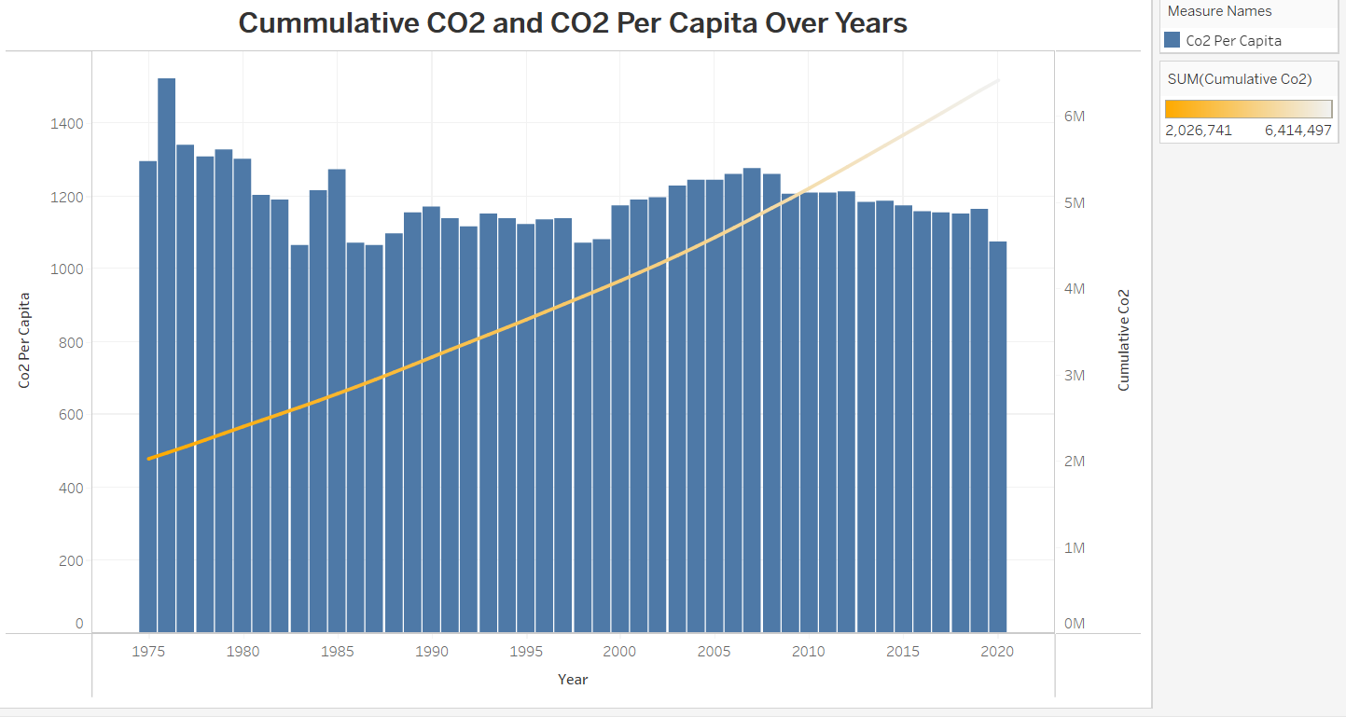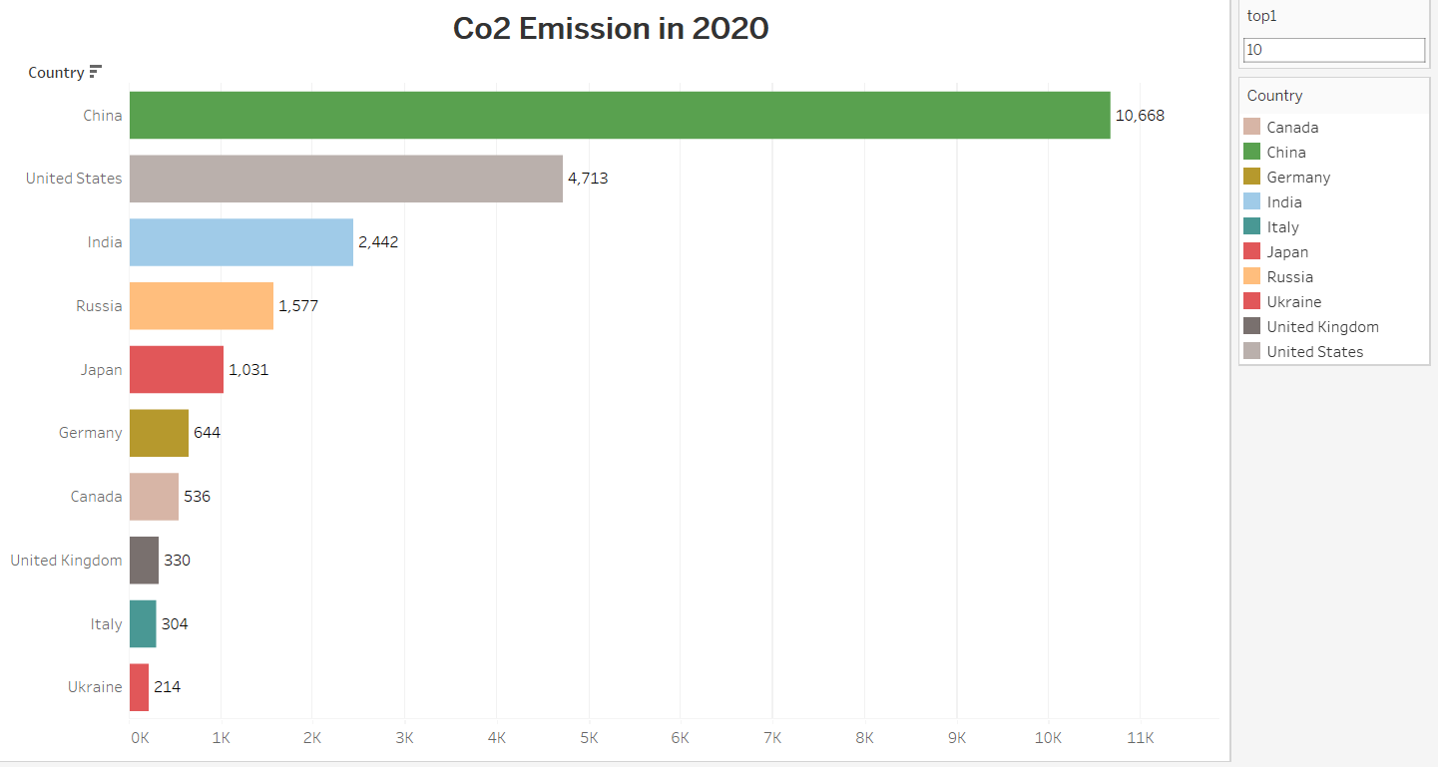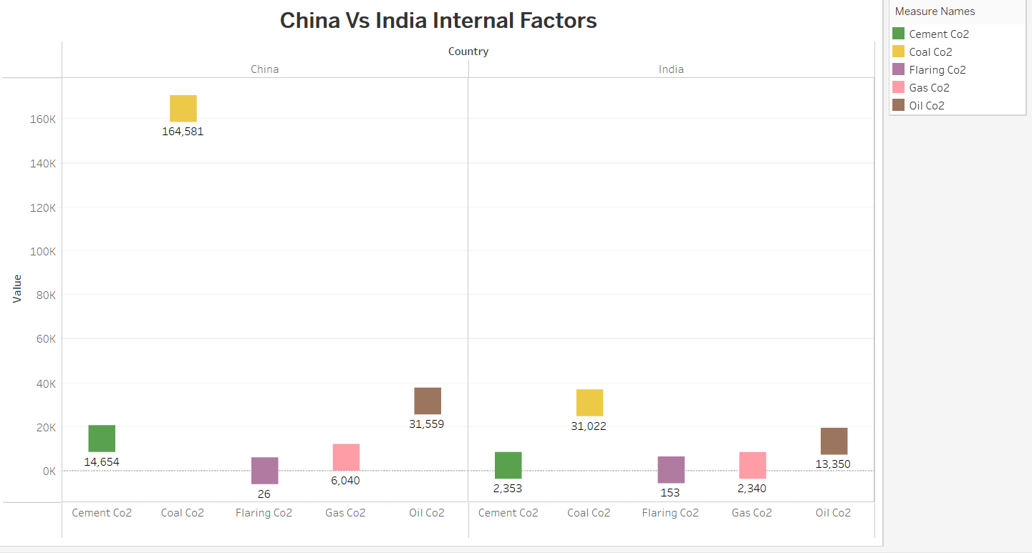

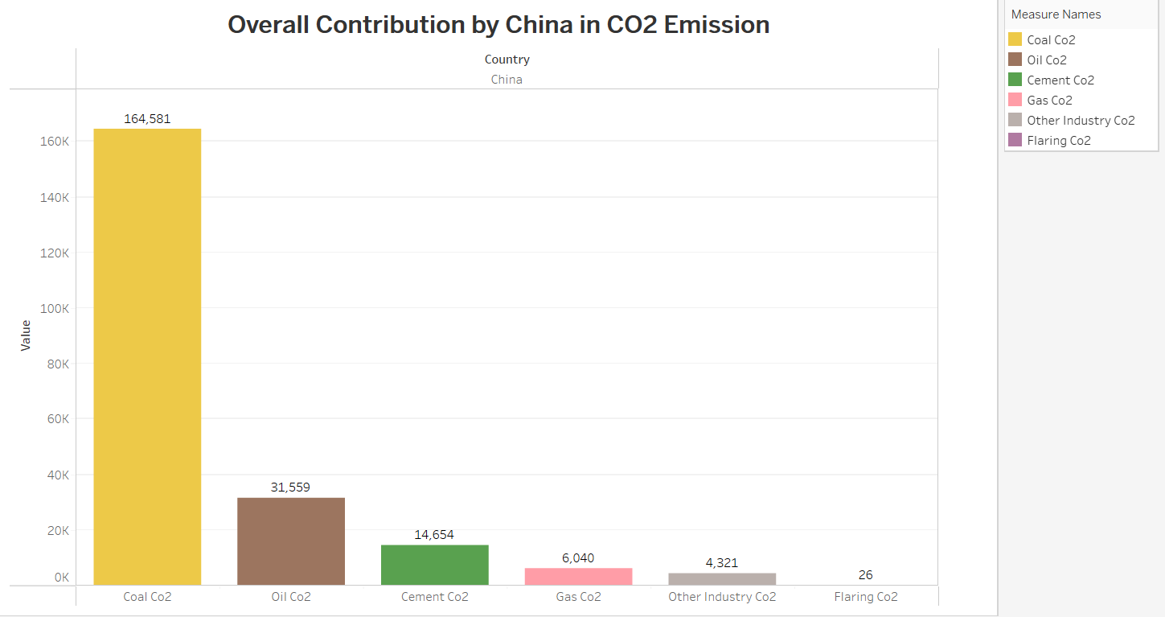

**ADVANTAGES AND DISADVANTAGES**

**ADVANTAGES:**

* Awareness: By analyzing global CO2 emissions, we can become more aware of the magnitude of our impact on the environment. This can help us understand the urgency of the situation and motivate us to take action to reduce our carbon footprint.
* Identifying sources of emissions: CO2 emission analysis can help us identify the sources of greenhouse gas emissions, such as transportation, agriculture, and energy production.This information can be used to develop targeted policies and initiatives to reduce emissions from these sectors.
* Developing solutions: By understanding the sources of CO2 emissions, we can develop and implement solutions to reduce them. For example, we can develop cleaner forms of energy, implement more efficient transportation systems, and promote sustainable agriculture practices.
* Mitigating climate change: Reducing global CO2 emissions is crucial to mitigating the impacts of climate change, such as rising sea levels, extreme weather events, and loss of biodiversity

**DISADVANTAGES:**

* CO2 Emissions : Disadvantages of co2 emission There are several disadvantages of carbon dioxide (CO2) emissions,
* Climate Change: CO2 emissions are the primary contributor to climate change. As the concentration of CO2 in the atmosphere increases, it traps more heat and leads to global warming, causing a range of adverse effects such as sea-level rise, extreme weather events, and loss of biodiversity.
* Health Impacts: CO2 emissions can also have significant negative impacts on human health, particularly for those living in urban areas with high levels of pollution. Exposure to air pollution can cause respiratory problems such as asthma, bronchitis, and lung cancer.
* Ocean Acidification: When CO2 is absorbed by the oceans, it reacts with water to form carbonic acid, leading to a decrease in pH levels. This process is known as ocean acidification, which has a range of impacts on marine ecosystems, such as decreased growth rates of organisms with she.

**APPLICATION**

* Analyzing global CO2 emissions is an important step in understanding the environmental impact of human activity. Here are some steps you can take to conduct such an analysis
* Collect Data: Begin by collecting data on global CO2 emissions. There are many sources for this data, including the United Nations Framework Convention on Climate Change (UNFCCC) and the Global Carbon Project. You can also look for data from individual countries or regions.
* Analyze Trends: Once you have collected the data, analyze the trends in global CO2 emissions over time. Look for patterns and changes in emissions levels, and try to identify the factors that contribute to these changes.
* Compare Regions: Compare CO2 emissions across different regions and countries to identify the areas with the highest levels of emissions. Look for correlations between emissions and factors such as population density, economic development, and energy consumption.

**CONCLUSION**

* Based on the scientific consensus, it is clear that human activities such as burning fossil fuels, deforestation, and industrial processes are major contributors to the increase in atmospheric CO2 concentrations, which is causing global warming and climate change.
* To address this issue, reducing greenhouse gas emissions, transitioning to renewable energy sources, and increasing energy efficiency are essential steps to mitigate the impact of climate change. Additionally, efforts to increase public awareness and education on the importance of reducing CO2 emissions and taking action to combat climate change are also necessary.

**FUTURE SCOPE**

* Future of Climate Research :Future scope of unearthing the environment impact of human activity a global co2 emission.
* The future scope of unearthing the environmental impact of human activity and global CO2 emissions is vast and multifaceted. Here are some potential areas of focus
* Advancements in remote sensing and monitoring technology: As remote sensing and monitoring technology continues to improve, scientists will have an increasingly detailed and accurate understanding of how human activity is affecting the environment.
* For example, satellite data can be used to track changes in land use and deforestation, while sensors can be deployed to measure air and water quality.
* Development of new modeling tools: As climate science becomes more complex, there is a need for new modeling tools to help researchers understand the complex interactions between human activity and the environment.

**APPENDIX**

* Carbon dioxide (CO2) is a greenhouse gas that contributes to global warming and climate change.
* It is emitted by a variety of human activities, including burning fossil fuels for energy, transportation, industrial processes, and deforestation.
* The concentration of CO2 in the atmosphere has increased significantly since the industrial revolution, and is currently at its highest level in at least 800,000 years.
* Global CO2 emissions have been increasing steadily over the past century, with the largest emitters being China, the United States, and India.